AWS WEB APPLICATION FIREWALL (WAF)

Use Cases
- Pre-create security rules before application deployment
- Centralized security configuration
- Learning and understanding AWS WAF rule creation
- Future attachment to ALB, API Gateway, or CloudFront

A Web Application Firewall (WAF) is a security service that protects web applications from common web attacks by filtering, monitoring, and blocking malicious HTTP/HTTPS requests.
In AWS, AWS WAF helps you:
- Control traffic to your web applications
- Block malicious users and bots
- Prevent attacks like SQL Injection, XSS, etc.
- Improve application security without changing your code

Core Concepts of AWS WAF
a) Web ACL (Access Control List)
A Web ACL is a set of rules that AWS WAF uses to allow, block, or count requests.
Each Web ACL contains:
- Rules
- Rule priority
- Default action (Allow or Block)

b) Rules
Rules define what traffic to allow or block.
Example rules:
- Block IPs from specific countries
- Block SQL injection patterns
- Block requests with suspicious headers
- Allow only specific user agents

c) Rule Groups
A rule group is a collection of rules.
Types:
- AWS Managed Rule Groups – Prebuilt by AWS (recommended)
- Marketplace Rule Groups – From security vendors
- Custom Rule Groups – Created by you

d) Conditions (Match Conditions)
Rules work based on conditions like:
- IP address
- Country
- HTTP headers
- Query string
- URI
- Body content
- Request rate (for DDoS-like behavior)
e) Actions
Each rule performs one of these actions:
- Allow – Let traffic pass
- Block – Deny traffic
- Count – Only monitor, don’t block (for testing)

f) Resources AWS WAF Can Protect
AWS WAF can be attached to:
- Application Load Balancer (ALB)
- Amazon CloudFront
- API Gateway

Benefits of AWS WAF
✅ No need to install software
✅ Fully managed
✅ Scales automatically
✅ Pay-as-you-go
✅ Works with CloudFront, ALB, API Gateway
✅ Real-time monitoring with CloudWatch

AWS WAF Architecture
AWS WAF works at Layer 7 (Application Layer) and protects your web applications by inspecting HTTP/HTTPS requests before they reach your application.

User/Client
↓
Internet
↓
CloudFront / ALB / API Gateway
↓
AWS WAF (Web ACL + Rules)
↓
If Allowed → Web Application (EC2 / ECS / EKS / Lambda)
If Blocked → Request Dropped

Step-by-Step Execution
Step 1:
Create Web ACL AWS Console Path: AWS Console → WAF & Shield → Web ACLs → Create web ACL
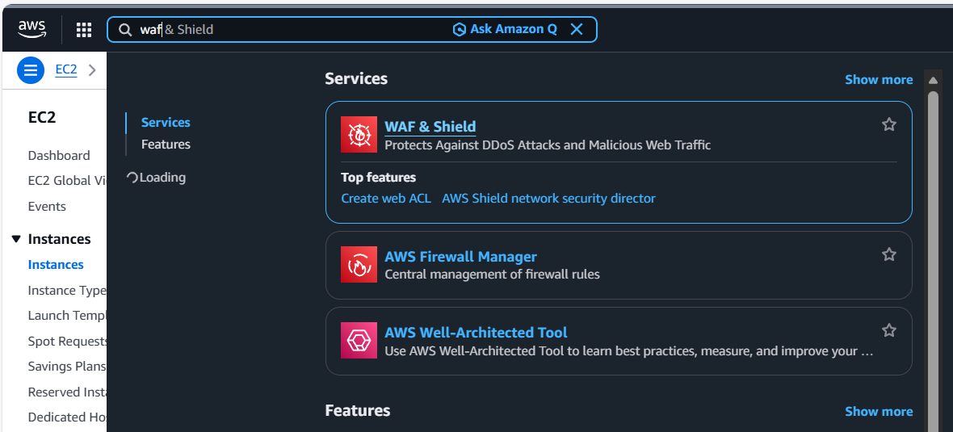

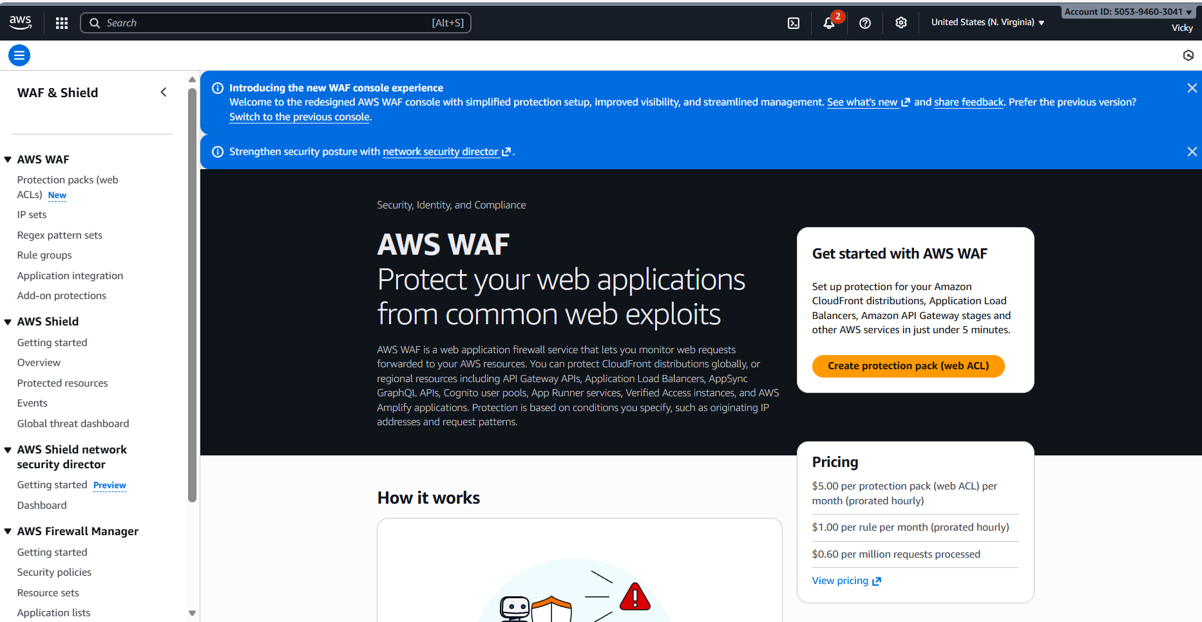
- Selected E-commerce and transaction platforms for app category.
- App focus- Both API and web
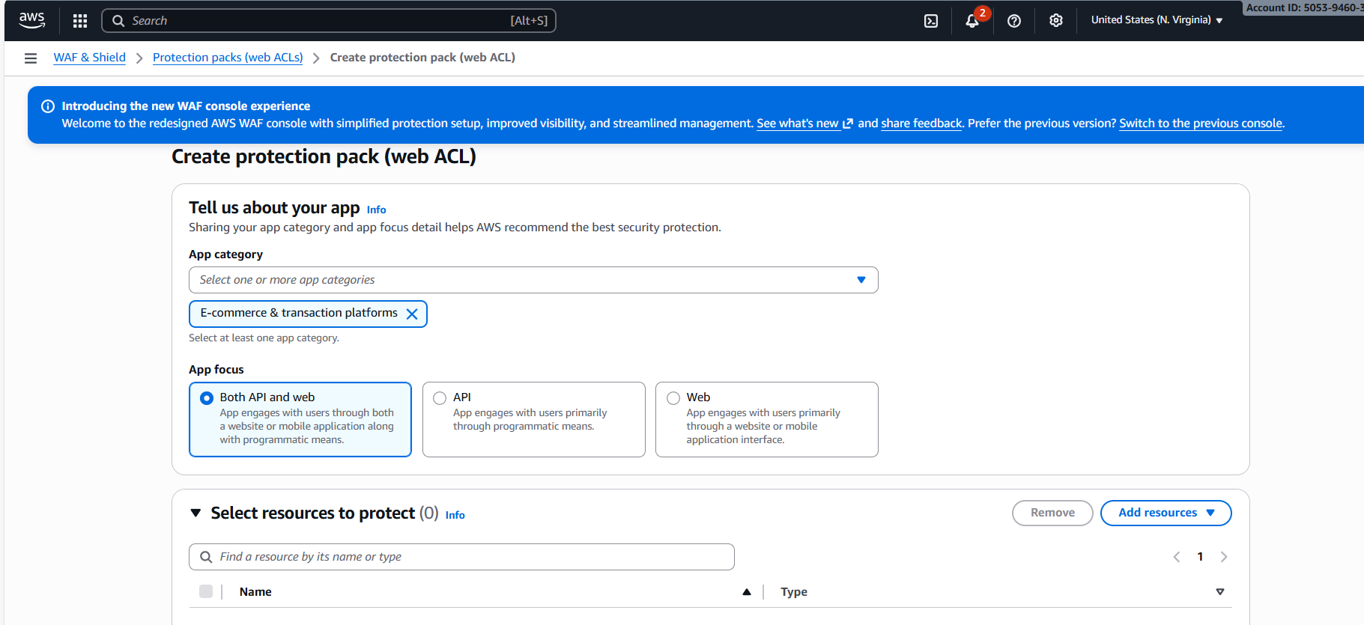

- Choose Protection pack (web ACL)-
  - AWS Amplify application, CloudFront distribution, and CloudFront distribution tenant
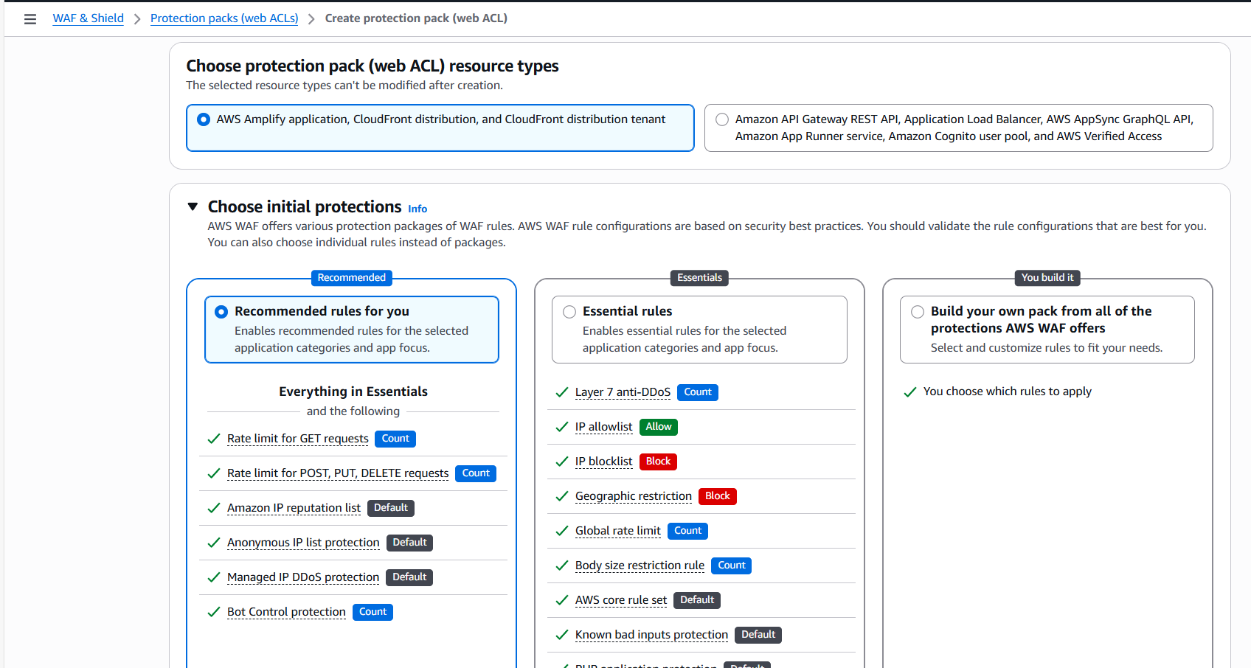

Selected CloudFront and Amplify related resource types for the Web ACL.
—> Choose Initial Protections What you did
- Selected Recommended rules for you
- Kept default recommended protections enabled

Name and Describe Protection Pack

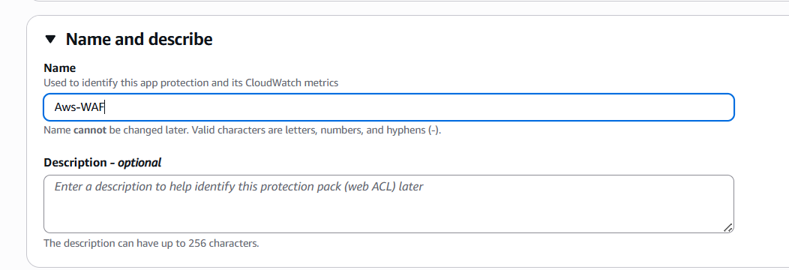

Create Protection Pack
- Reviewed all settings
- Clicked Create protection pack (web ACL)
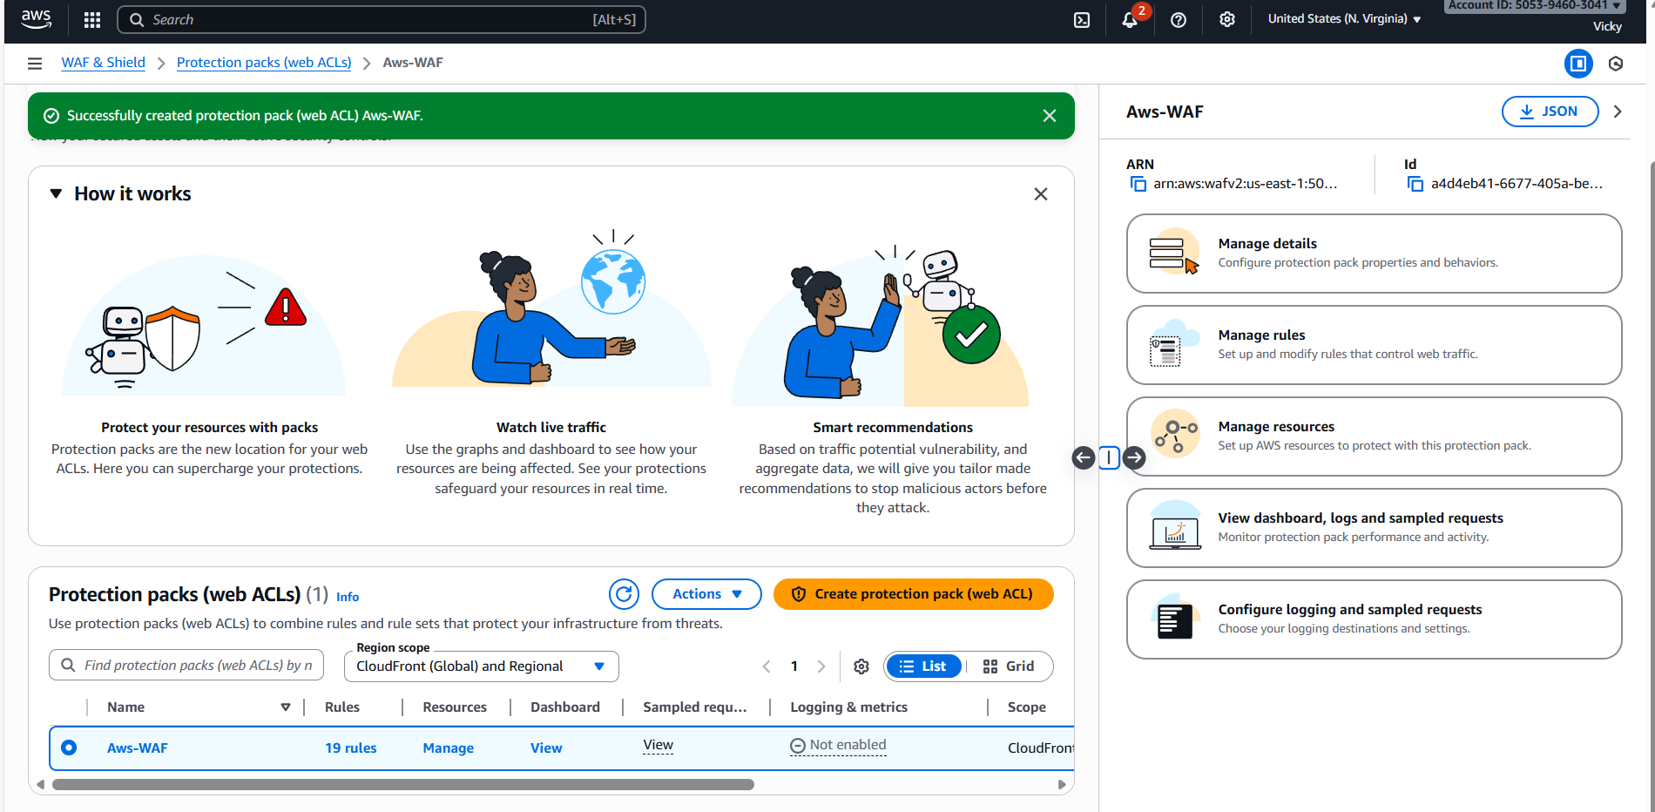

—> Protection Pack Created Successfully
Success message displayed
Protection pack status active
Rules enabled Conclusion : —> AWS WAF protection pack my-WAF-firewall was created successfully

